- Create a bash script to check if a directory is available or not.
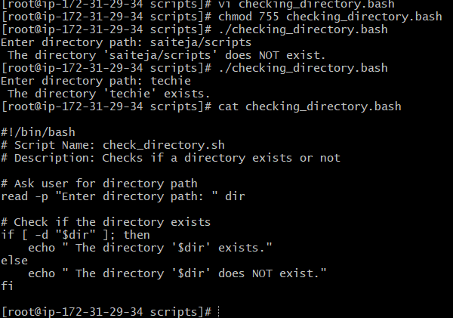

2.Create a bash script to create multiple files
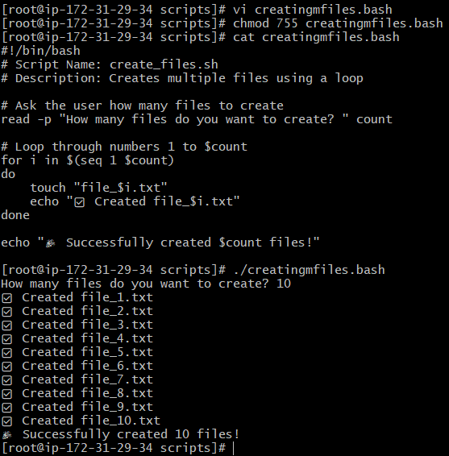
- Create a bash script to take a backup of a directory.
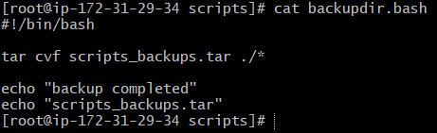
So together, ./* tells tar to include everything inside the current directory, but not the directory itself
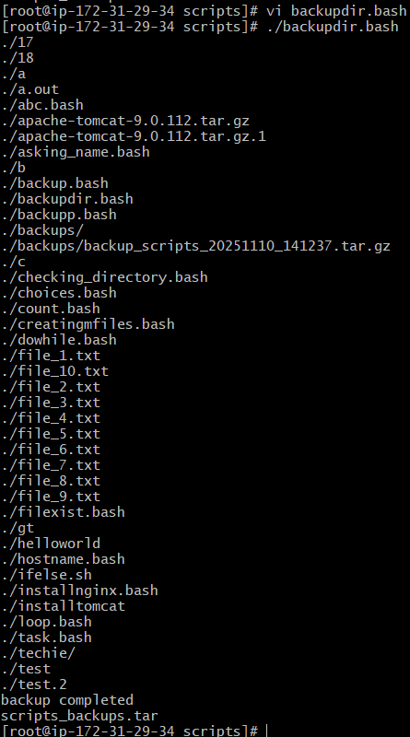

- Create a bash script to install nginx on ec2 server
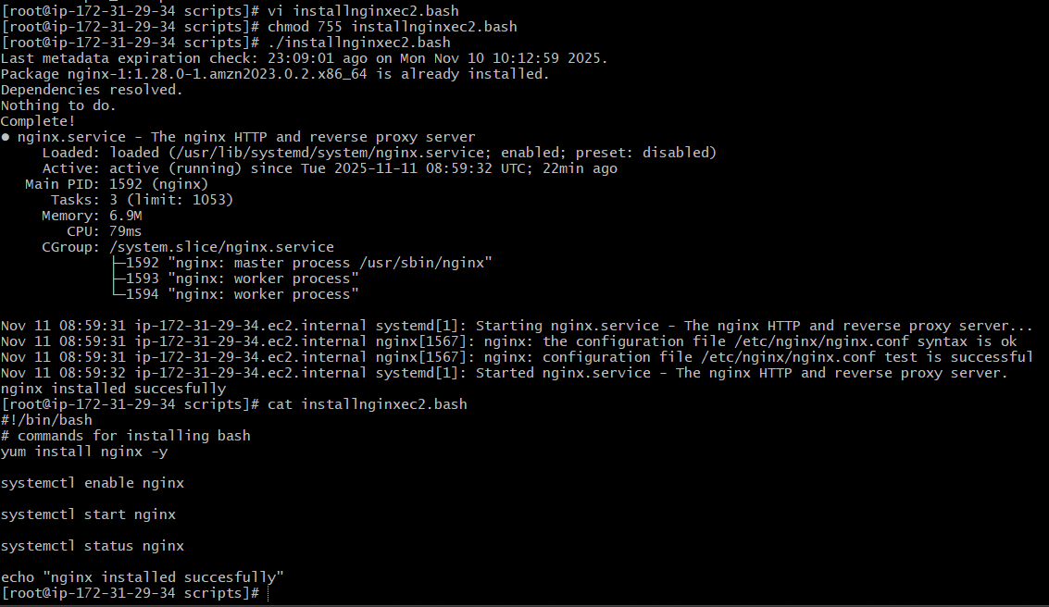

- Create a bash script to install apache -tomcat on EC2 server
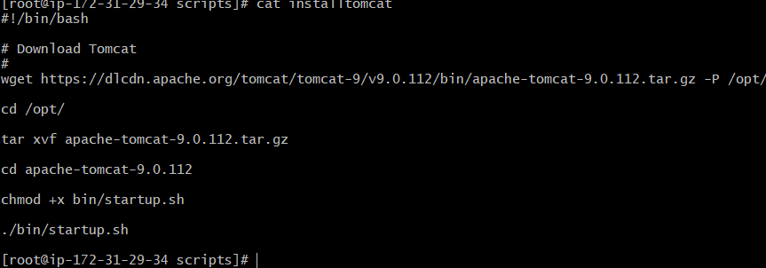
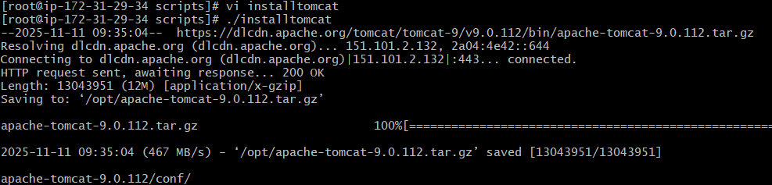

- Create a bash script to check if the Nginx service is running, if not running then script should start the service
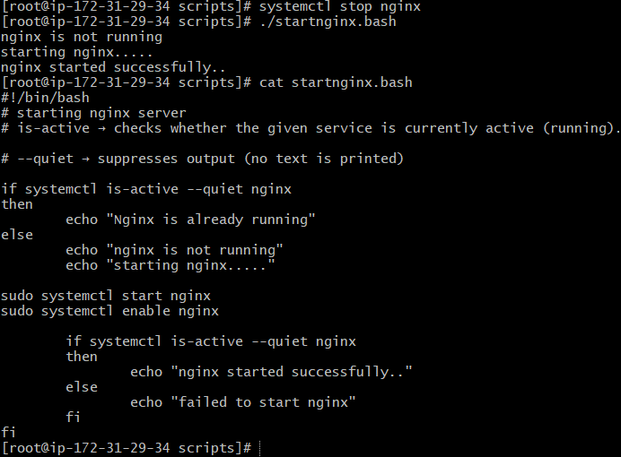

- Create a bash script for calculator
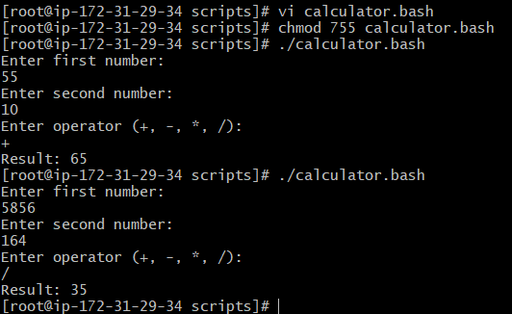
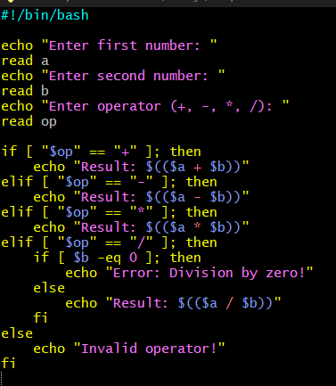
In simple code
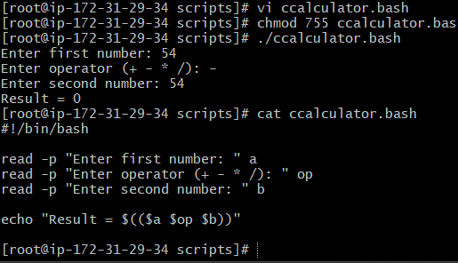

- Create a bash script to check if a directory exists, if not then create a directory.
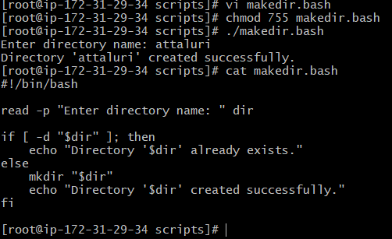
- Create a bash script to delete the last 3 lines of a file.
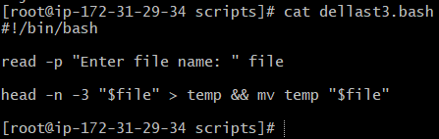
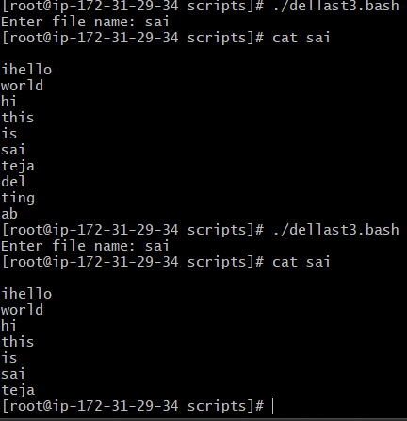

- Bash script to monitor cpu and if it is more than 80% then send email notification
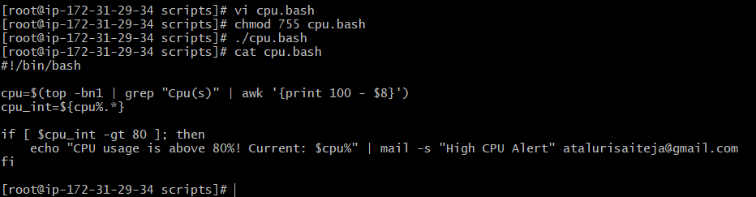

- Bash script to monitor disk space and if it is more than 80% then send email notification
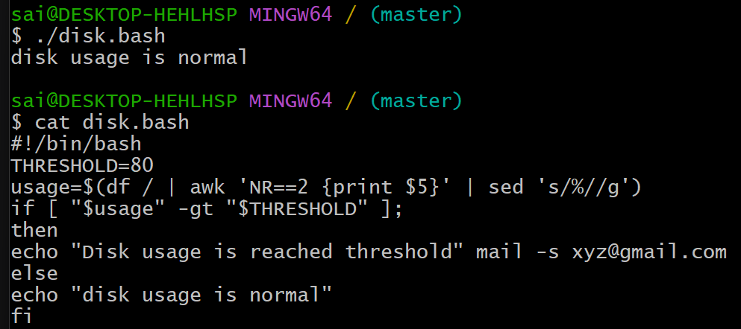
Command got run successfully if disk space reaches threshold then we will get notification
- Bash script to monitor memory and if it is more than 80% then send email notification.
